What is greedy technique:

See at each stage we take the optimal choice and then solve the problem. Example of that would be.

S is source and d is destination and all between is the path or choices in between. Here we need min cost to reach from S to D.

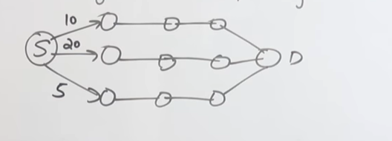

Here we can directly take 5 first as at this stage this is minimum. See consider the example of real life.

Consider you want to choose future field. You have done art in 11 and 12 and hence we can say here we can remove engineering as my future stream as I cannot select it. same for we selected medical field in college. hence after college we cannot select engineering as job option. See after all the feasible option available we select optimal solution that above will be min cost for optimal solution.